**Test suit**

A **Test Suite** in TestRail is a **collection of related test cases** grouped together to test a specific **feature, module, or functionality** of an application.

👉 Think of it like a **folder** that holds test cases for one area of the product.

**Example:**

* Login Test Suite
  + Valid login
  + Invalid password
  + Forgot password
* Registration Test Suite
  + New user signup
  + Email validation

**Adding test suit**

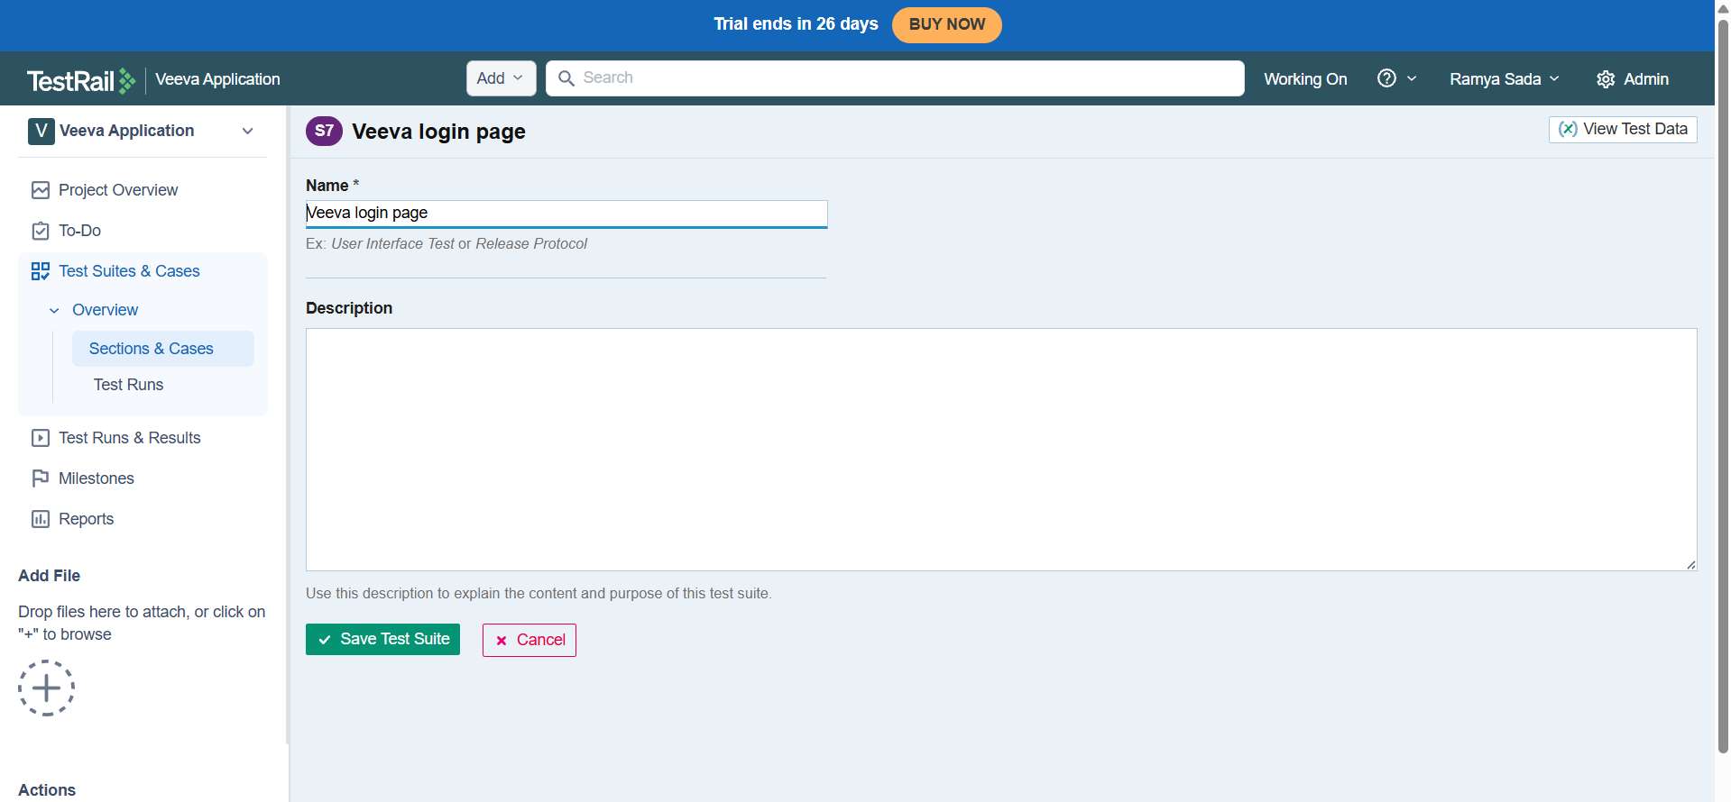

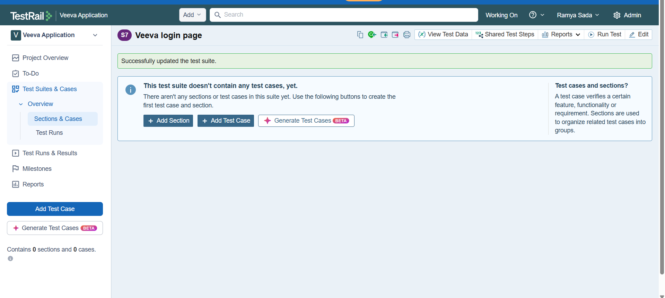

Adding testcase to the test suit

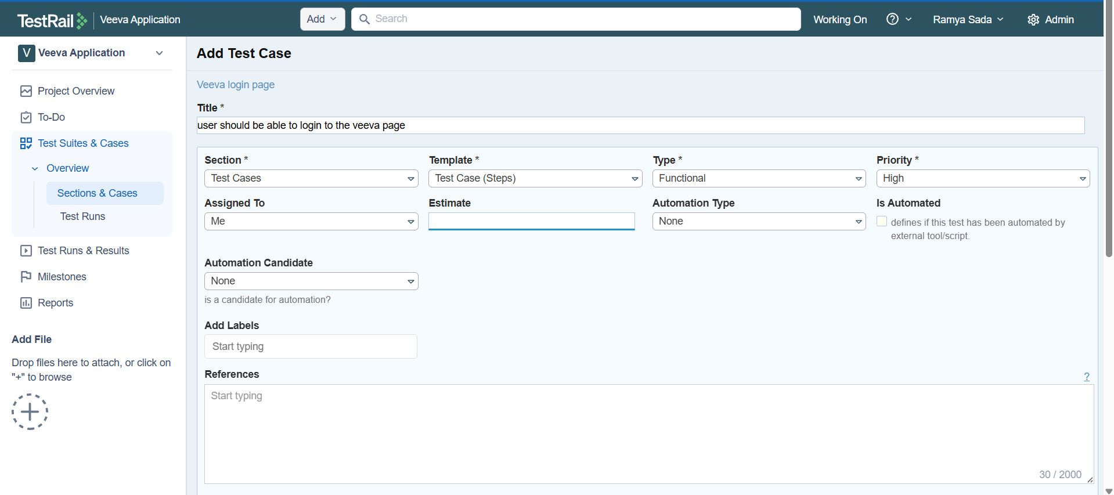

Select options based on the requirement

Adding test steps

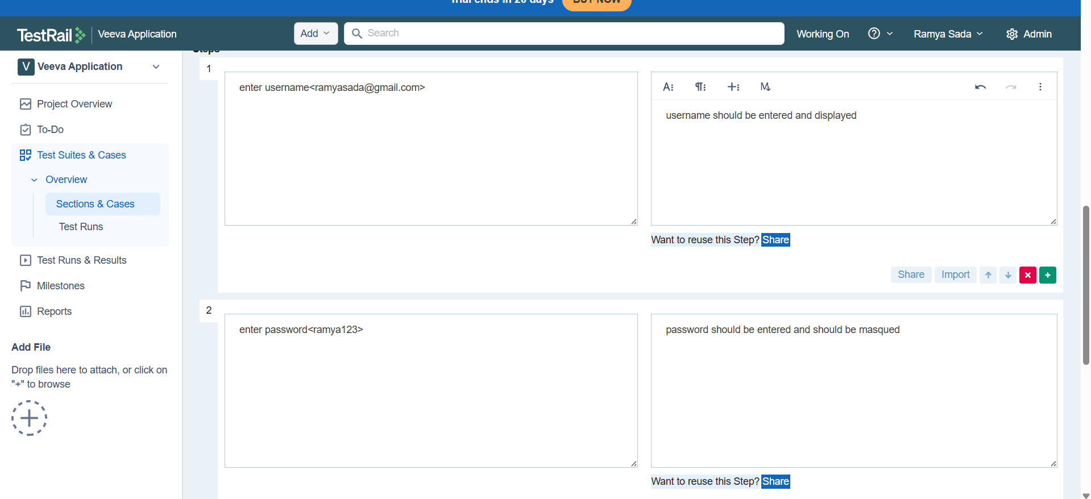

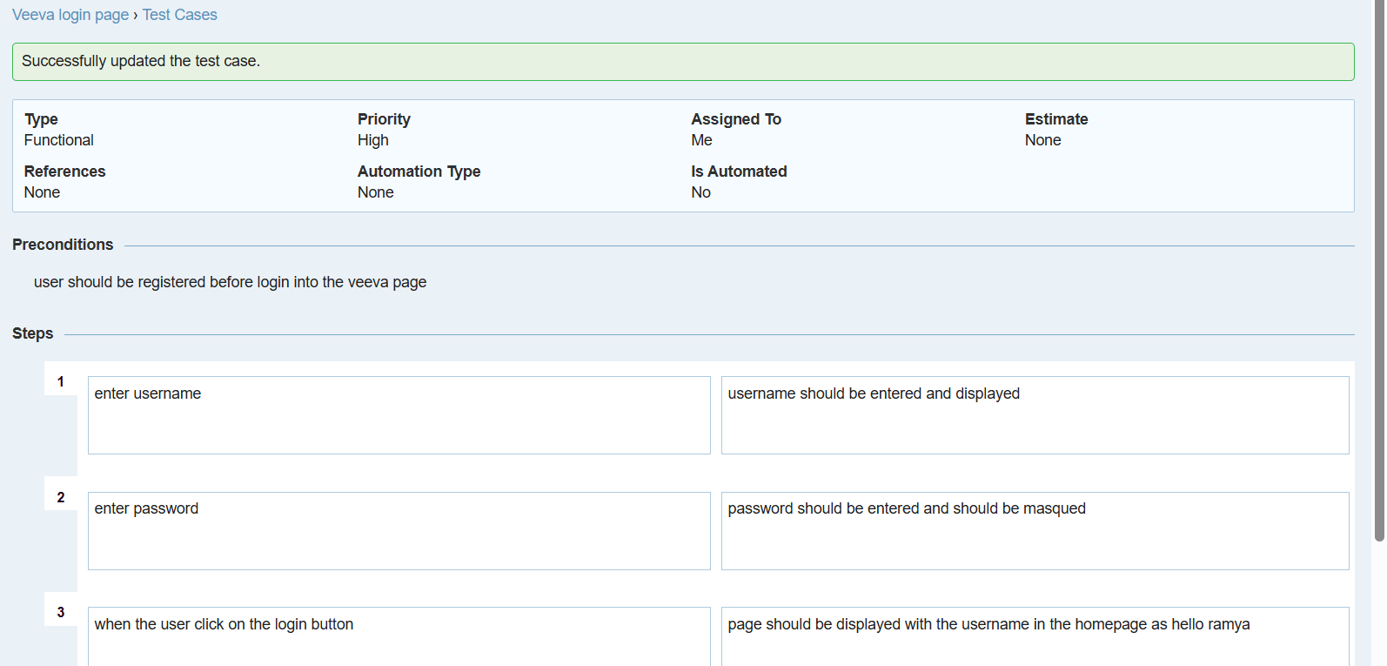

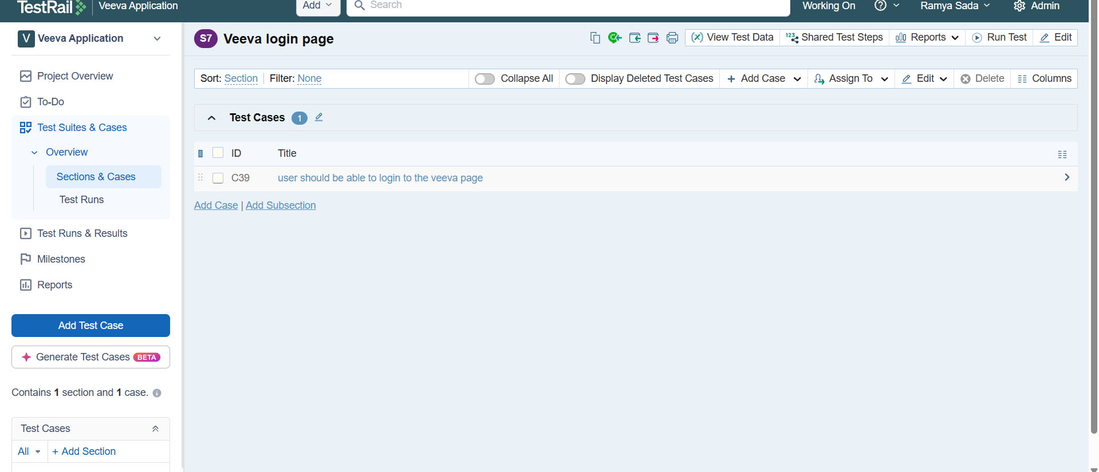

Adding another testcase

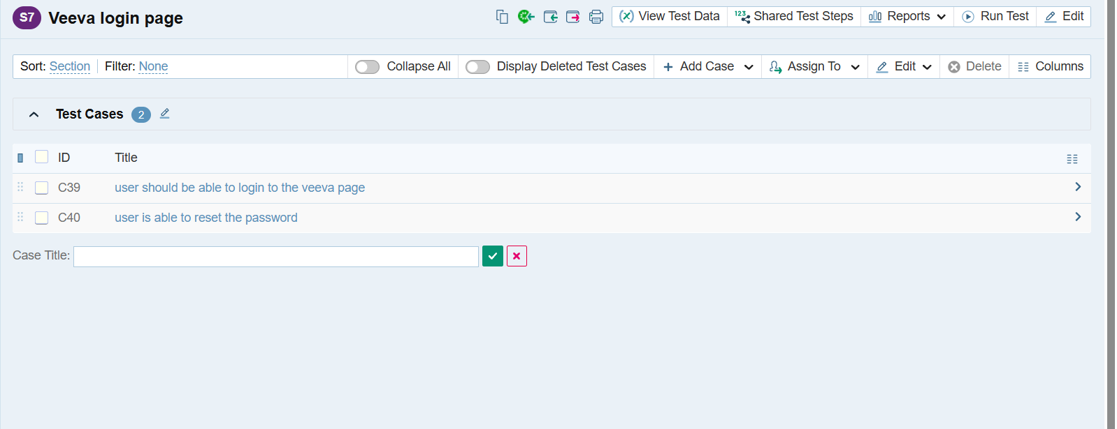

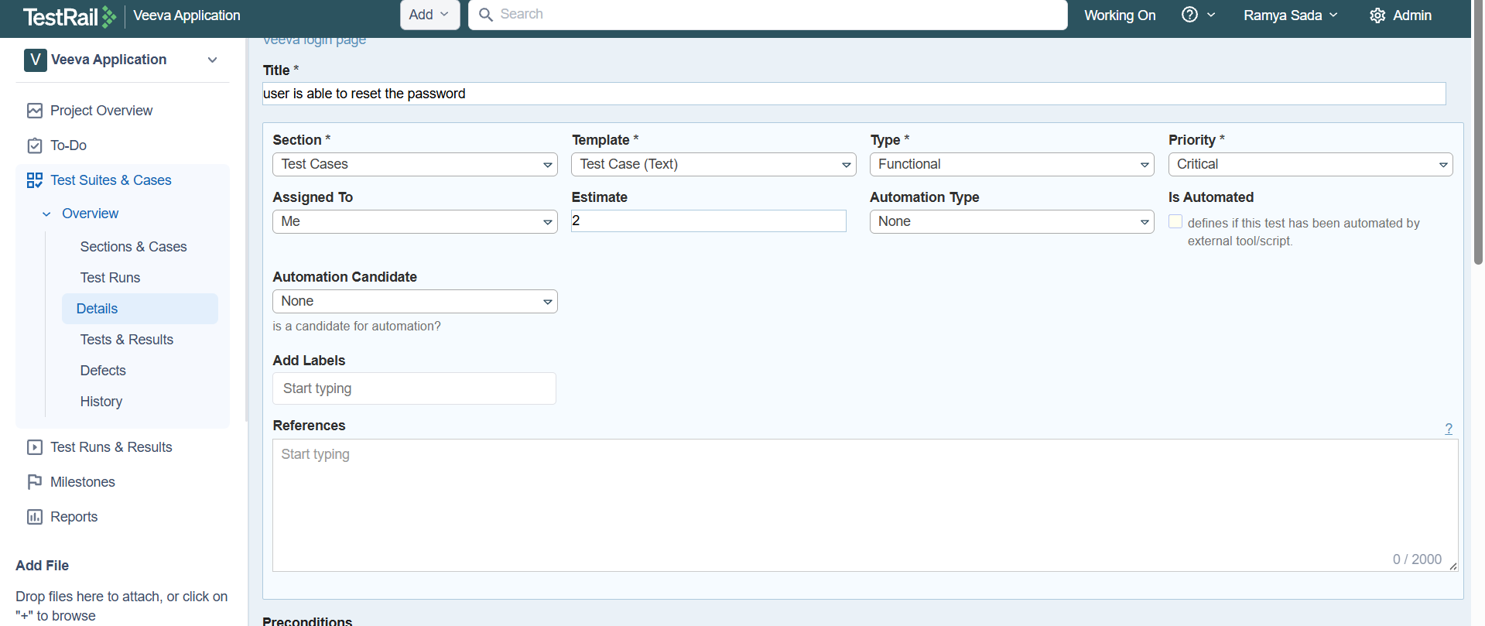

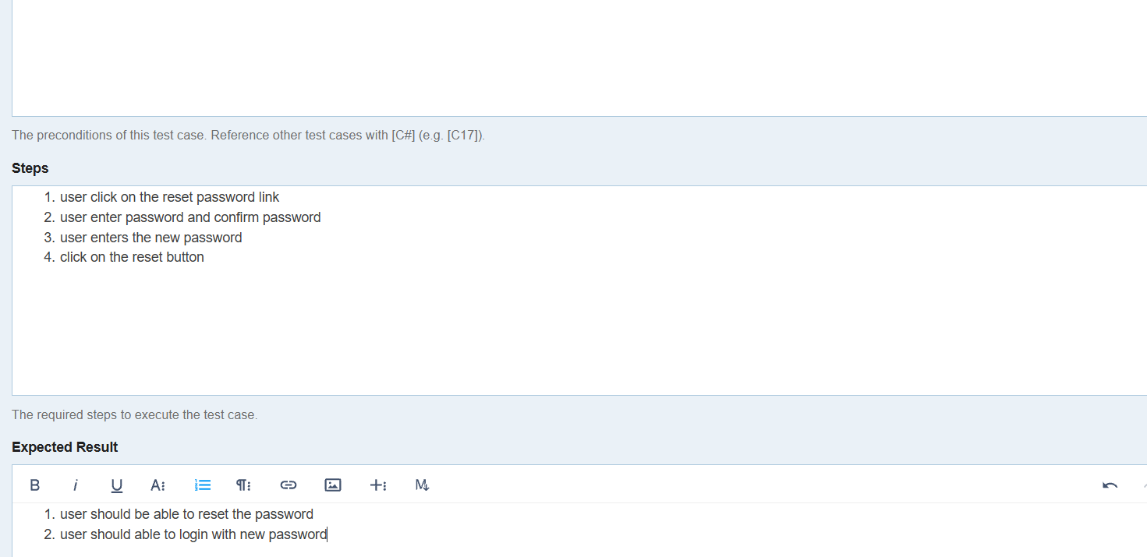

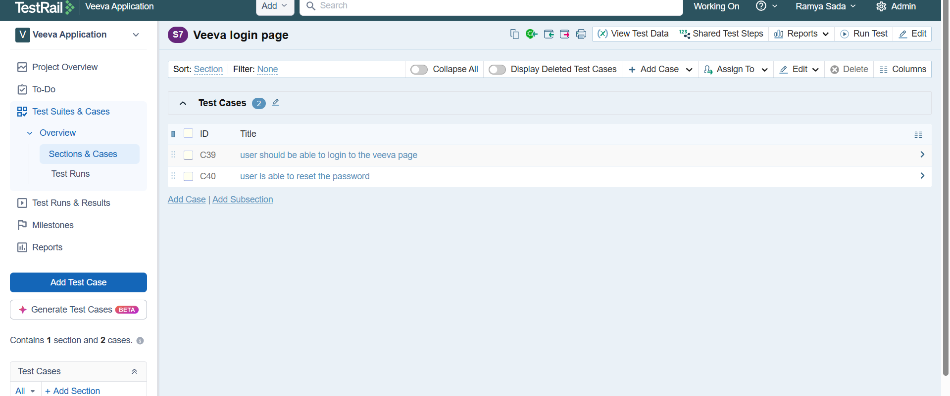

**Running the testcases**

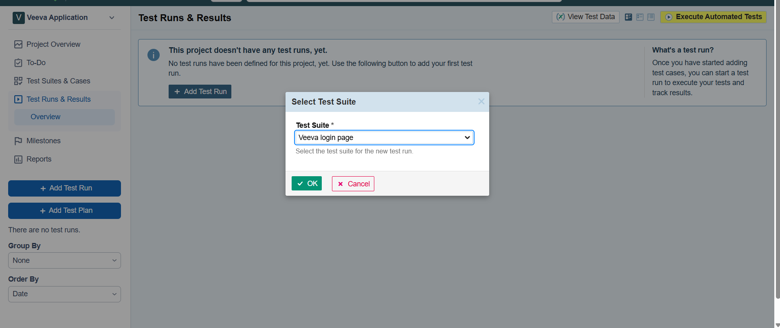

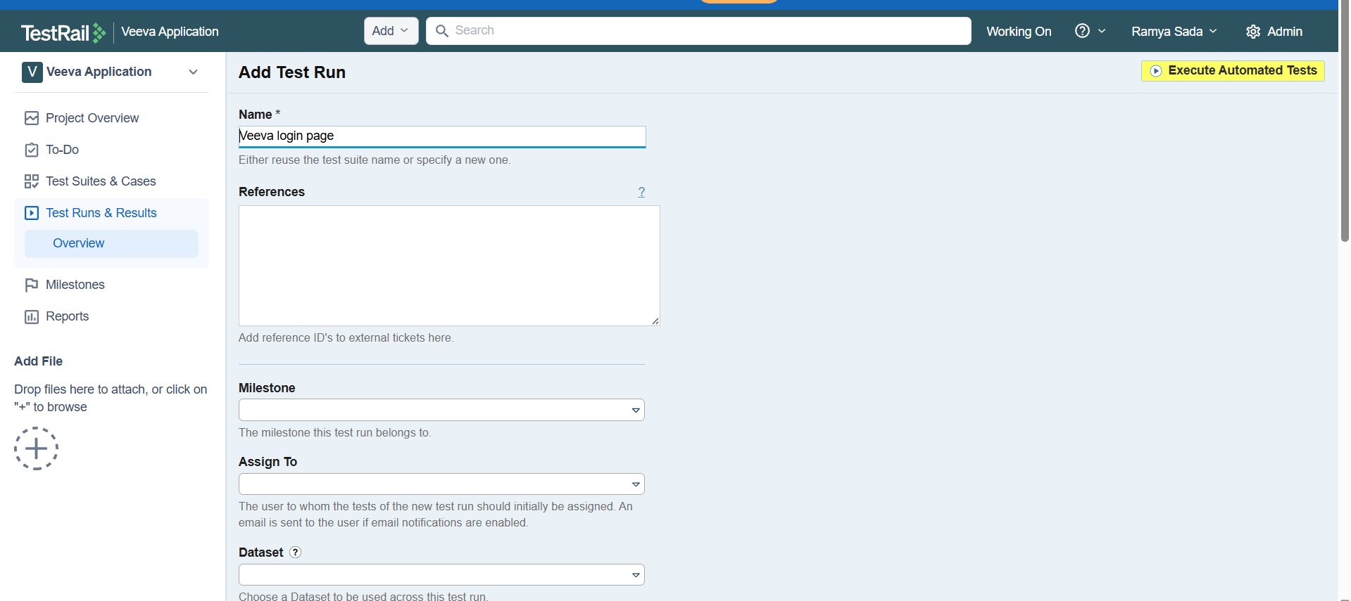

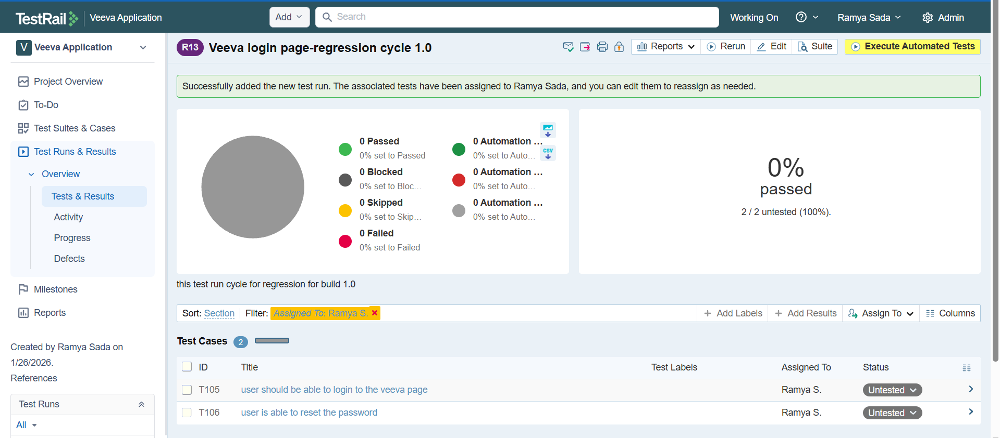

After clicking on the link of the testcase in the above image then

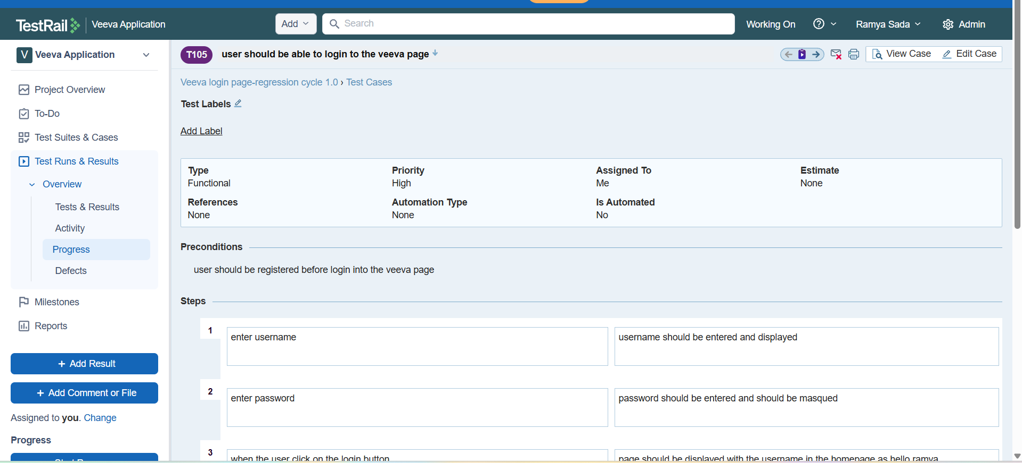

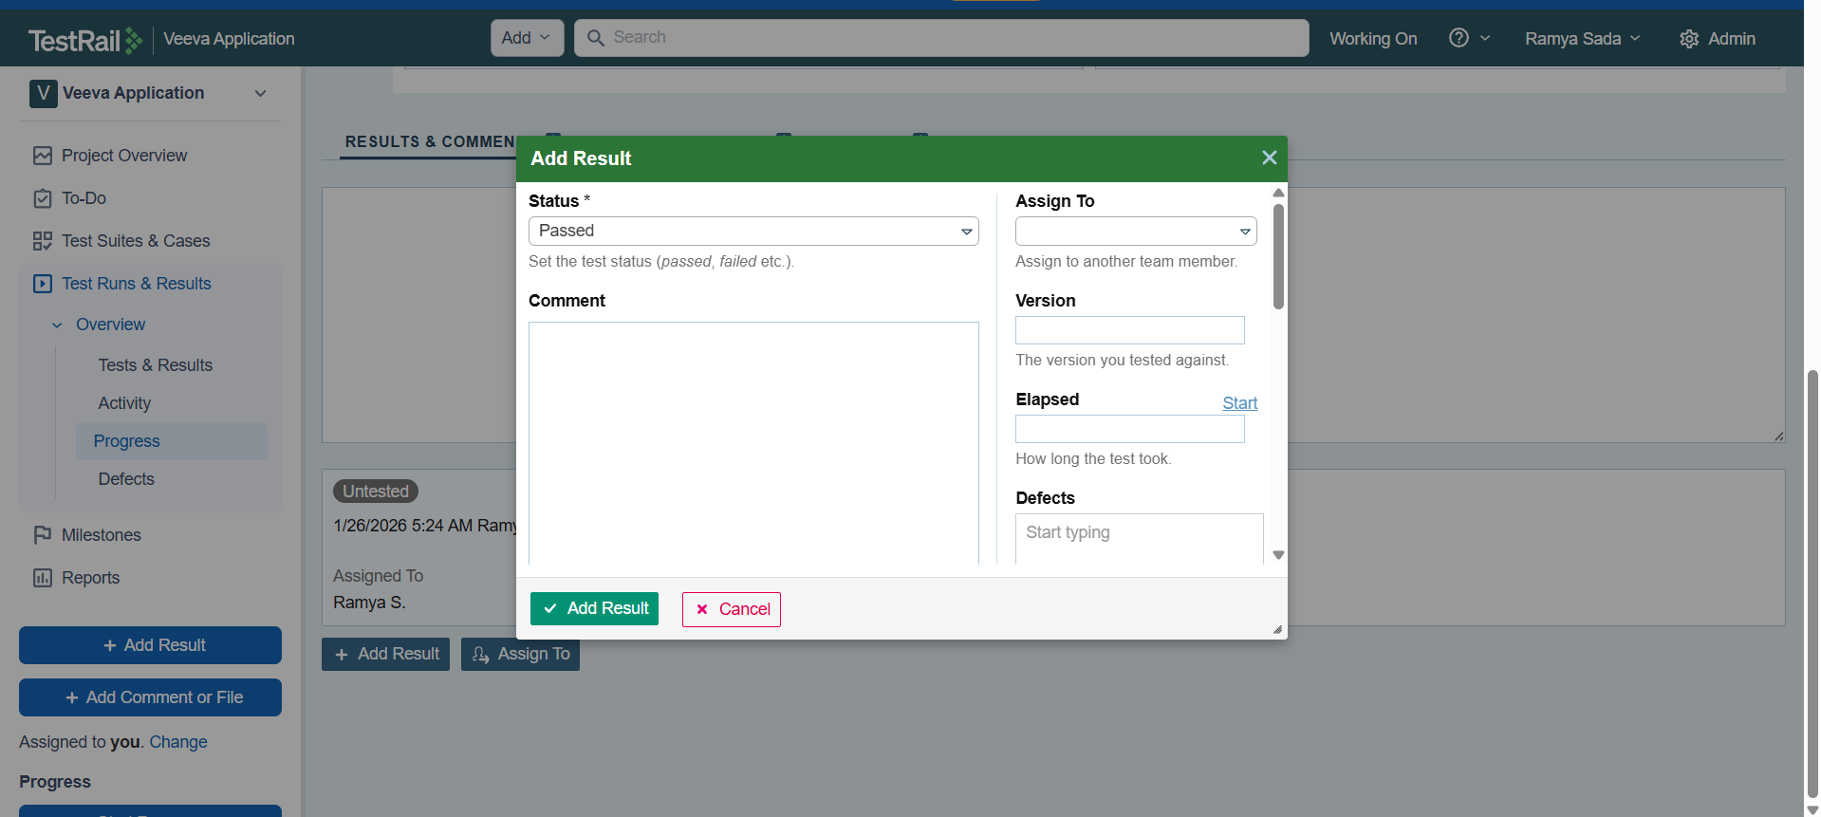

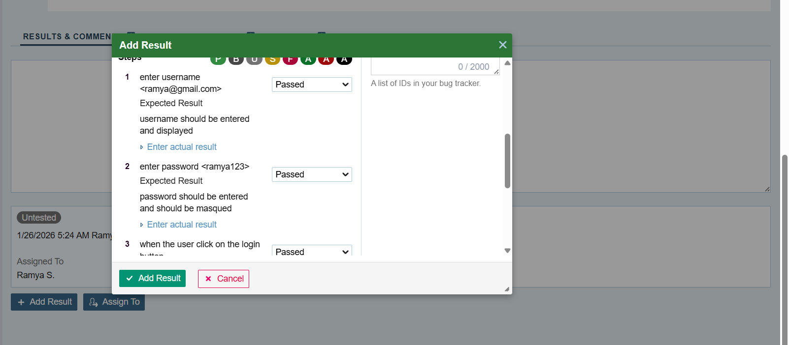

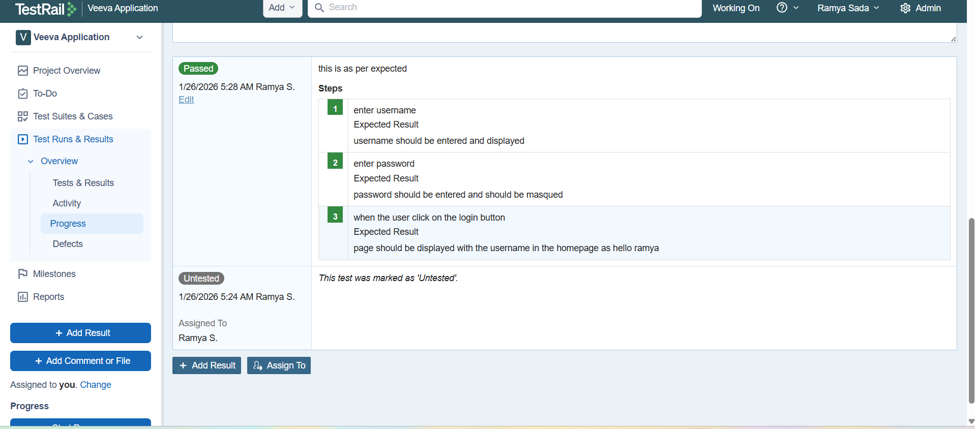

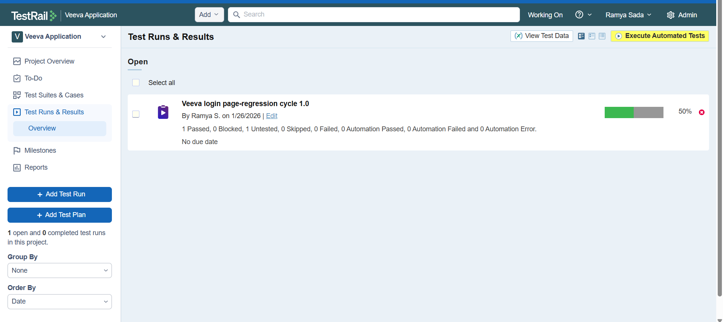

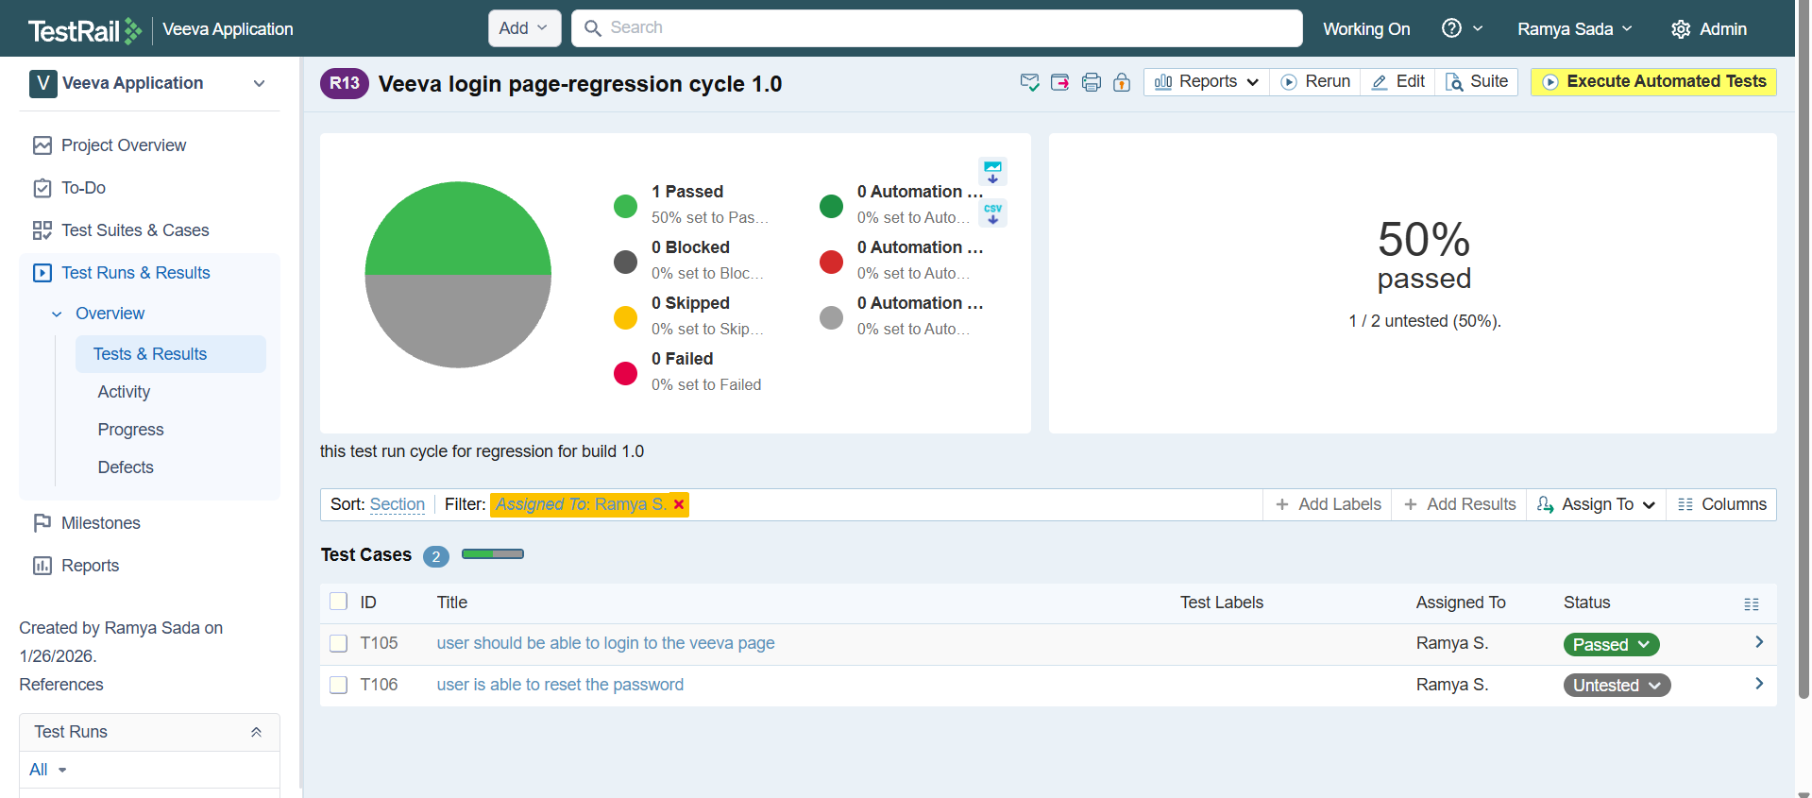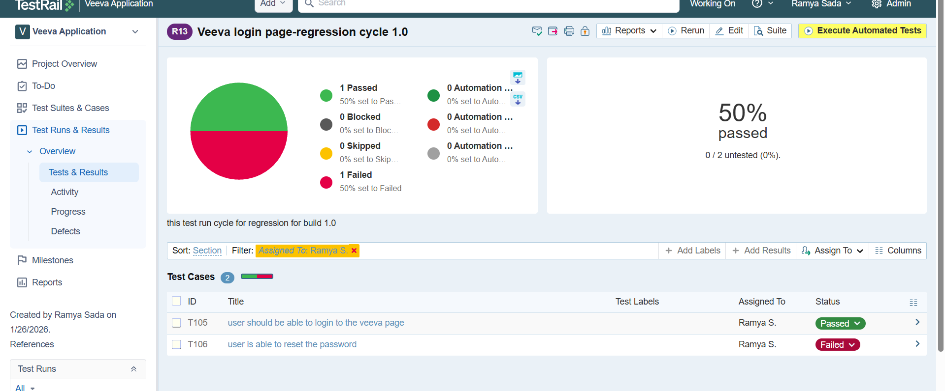

Adding section to a test suit

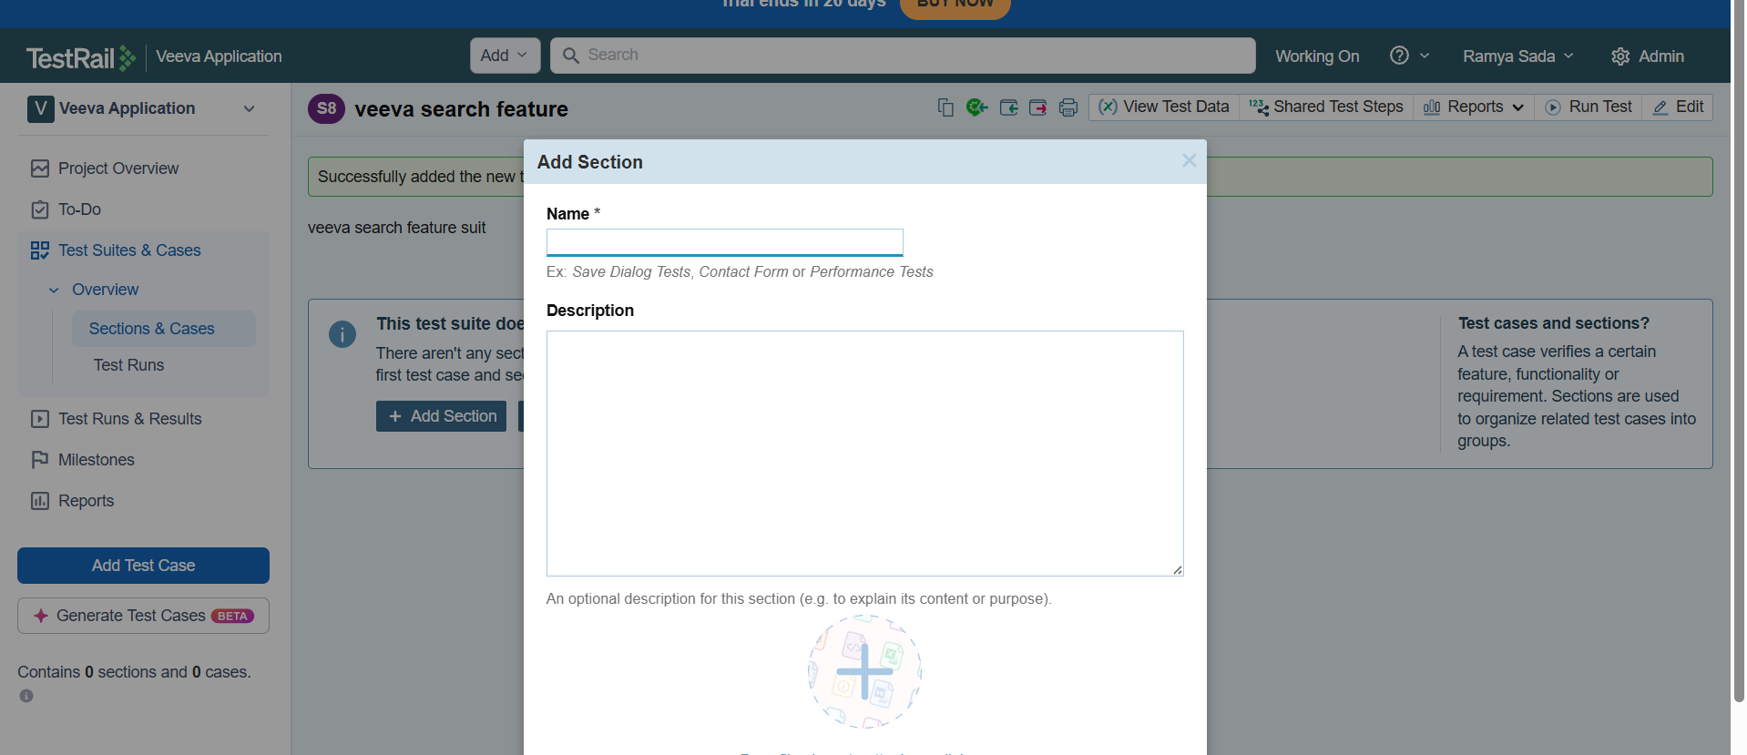

Adding testcase

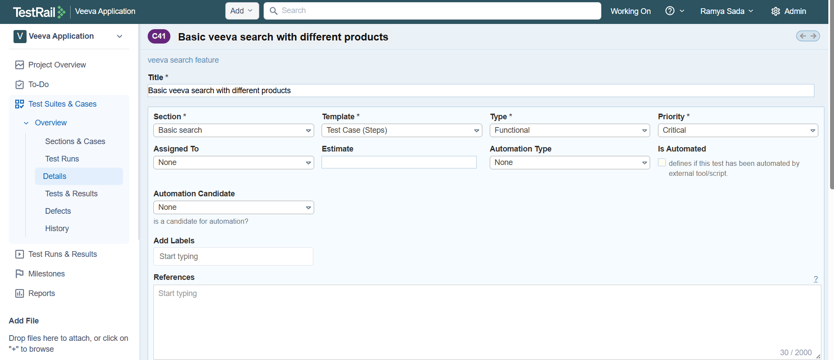

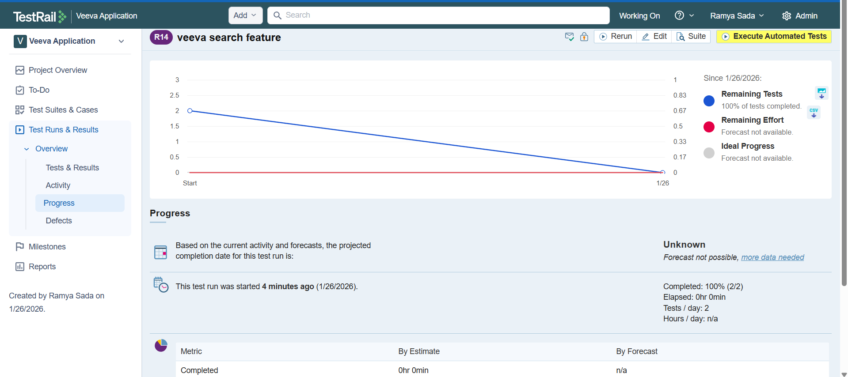

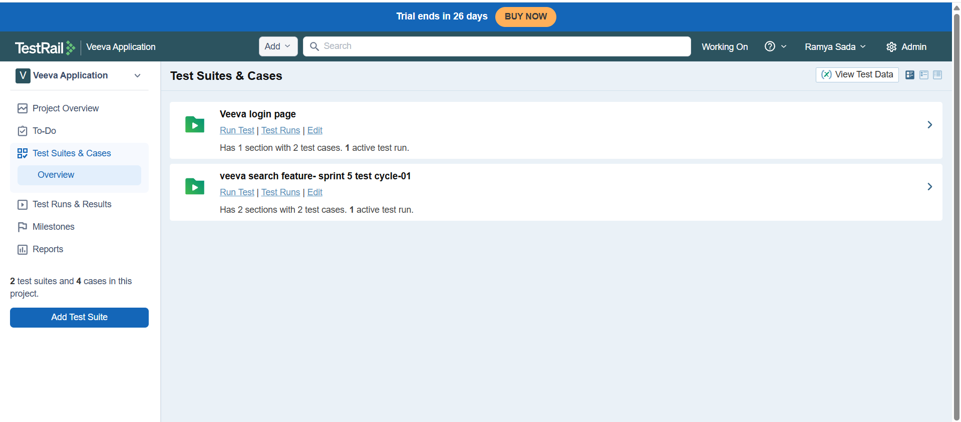

**What is a Test Plan?**

A **Test Plan** in TestRail is used to **manage and track multiple test runs together** for a release, version, or milestone of a project.

👉 Think of a Test Plan as a **container** that holds **many test runs**.

**Example:**

* Release 1.0 Test Plan
  + Chrome – Regression Test Run
  + Firefox – Smoke Test Run
  + Mobile – Sanity Test Run

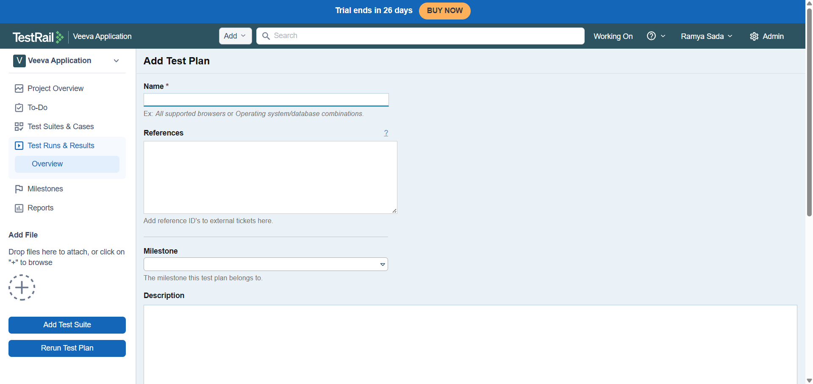

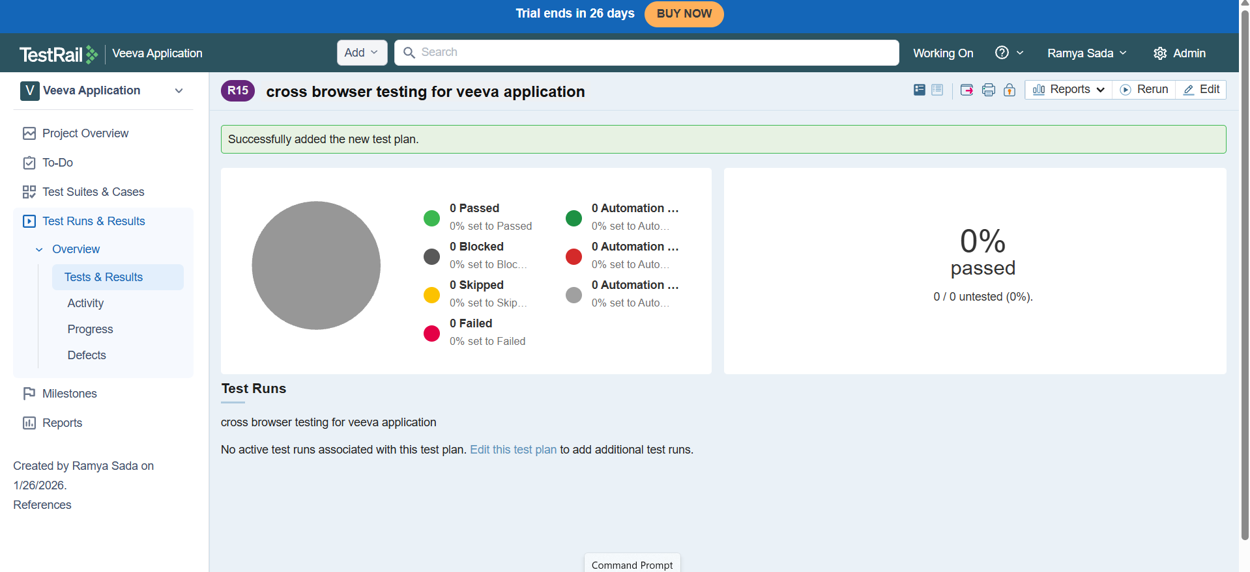

Adding test suit to the test plan

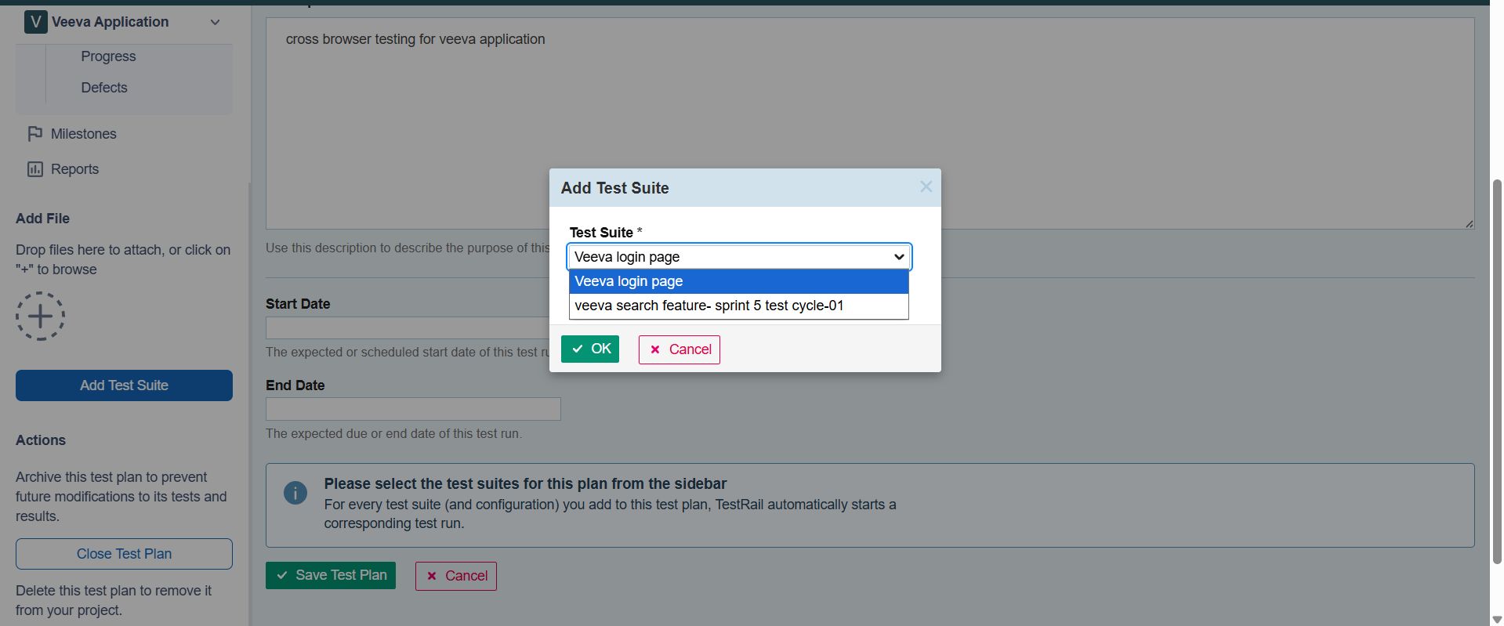

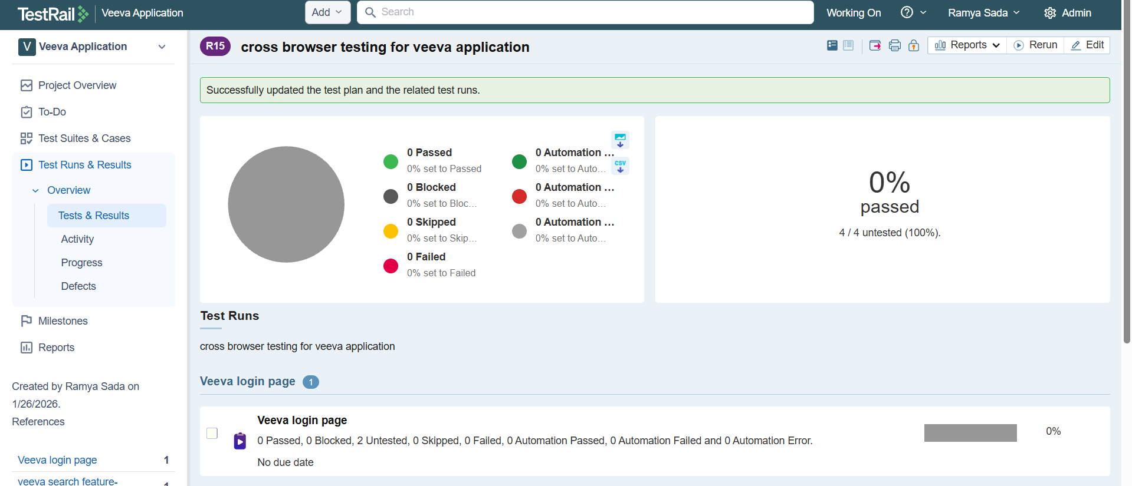

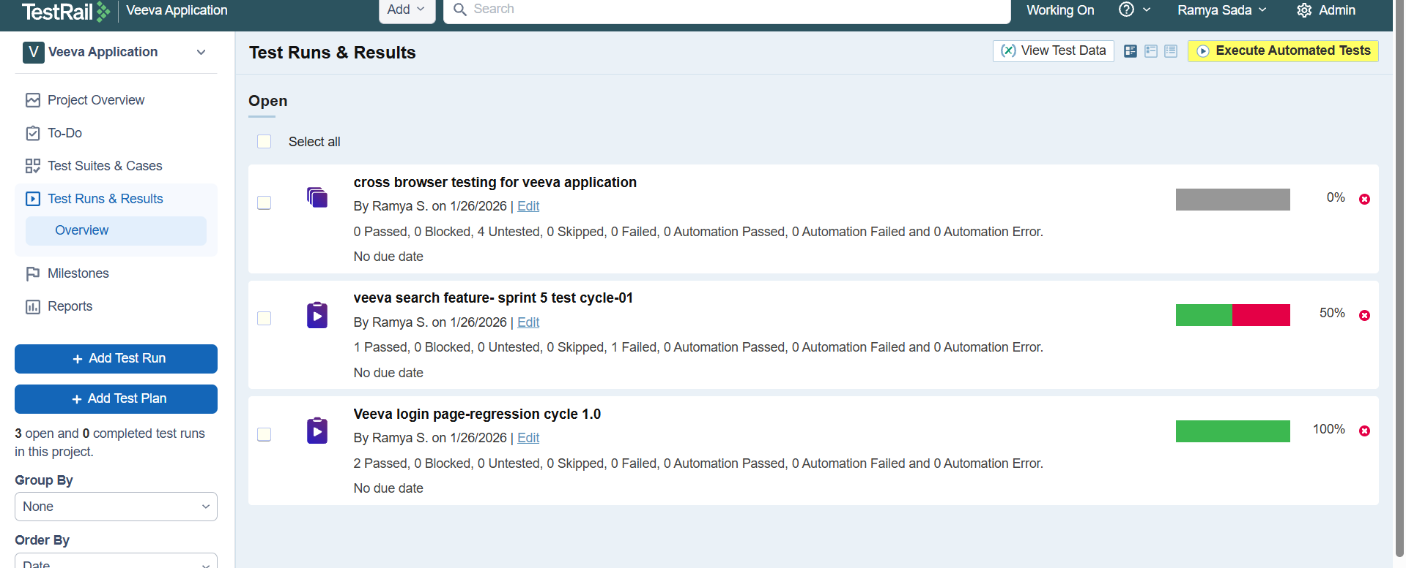

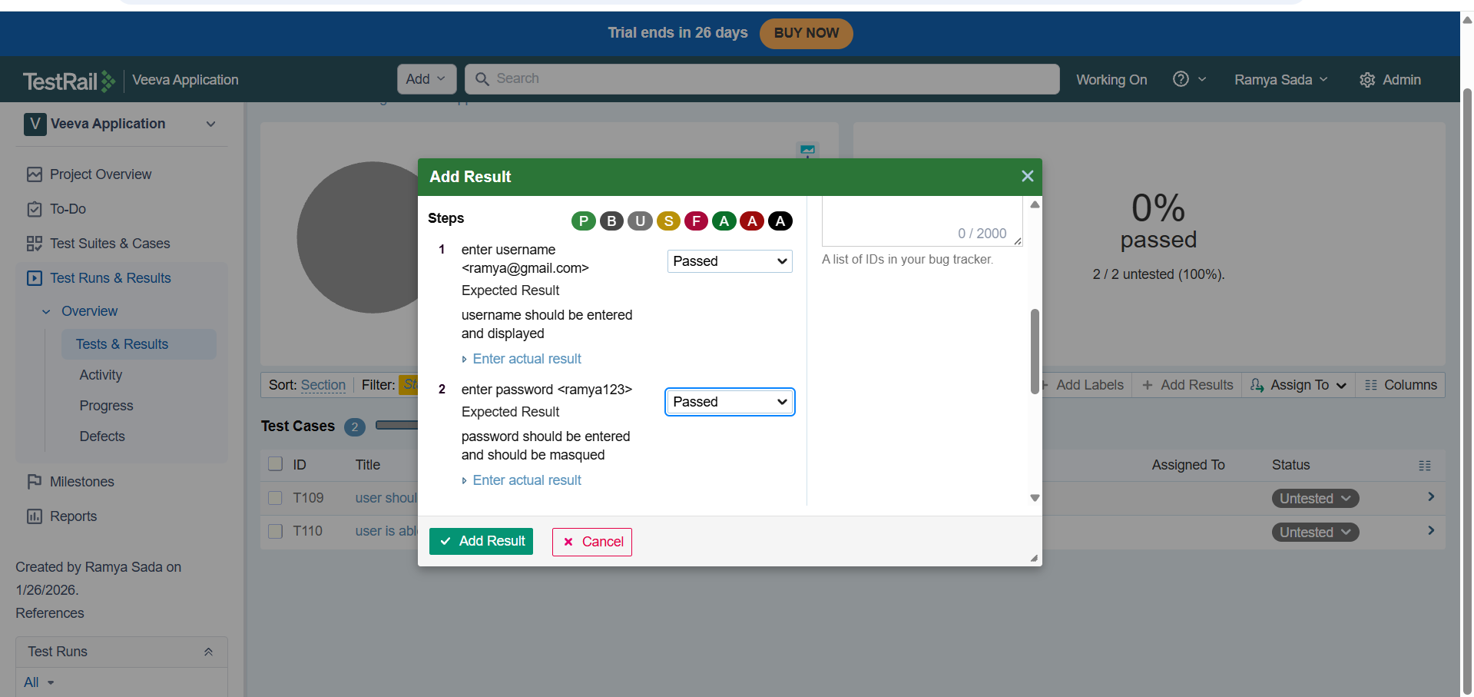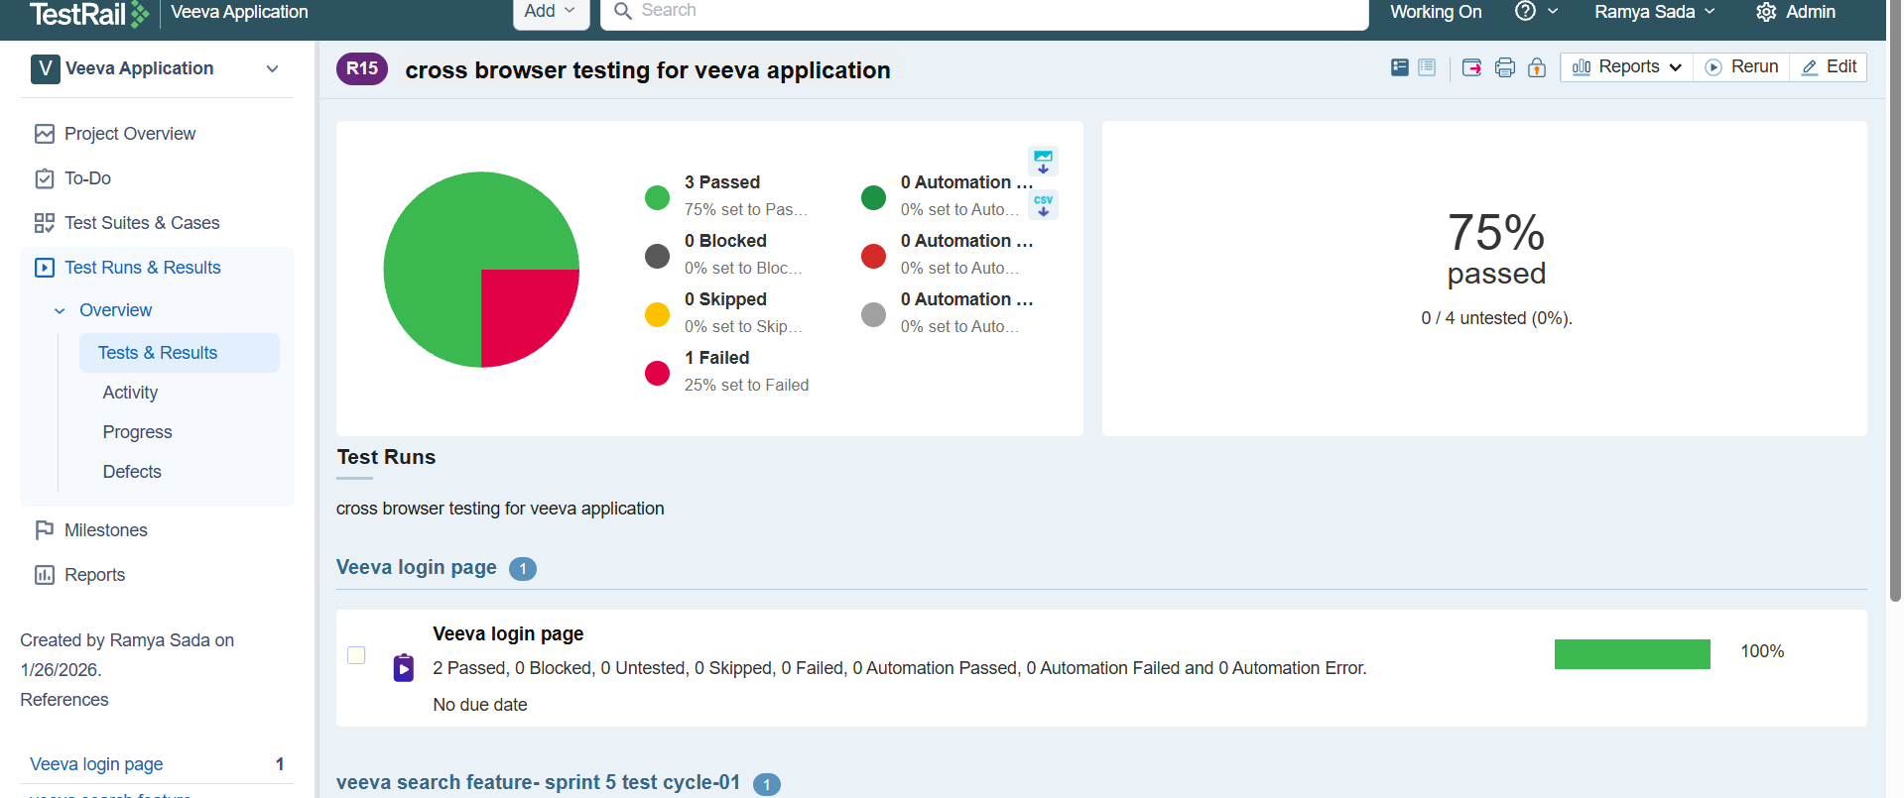

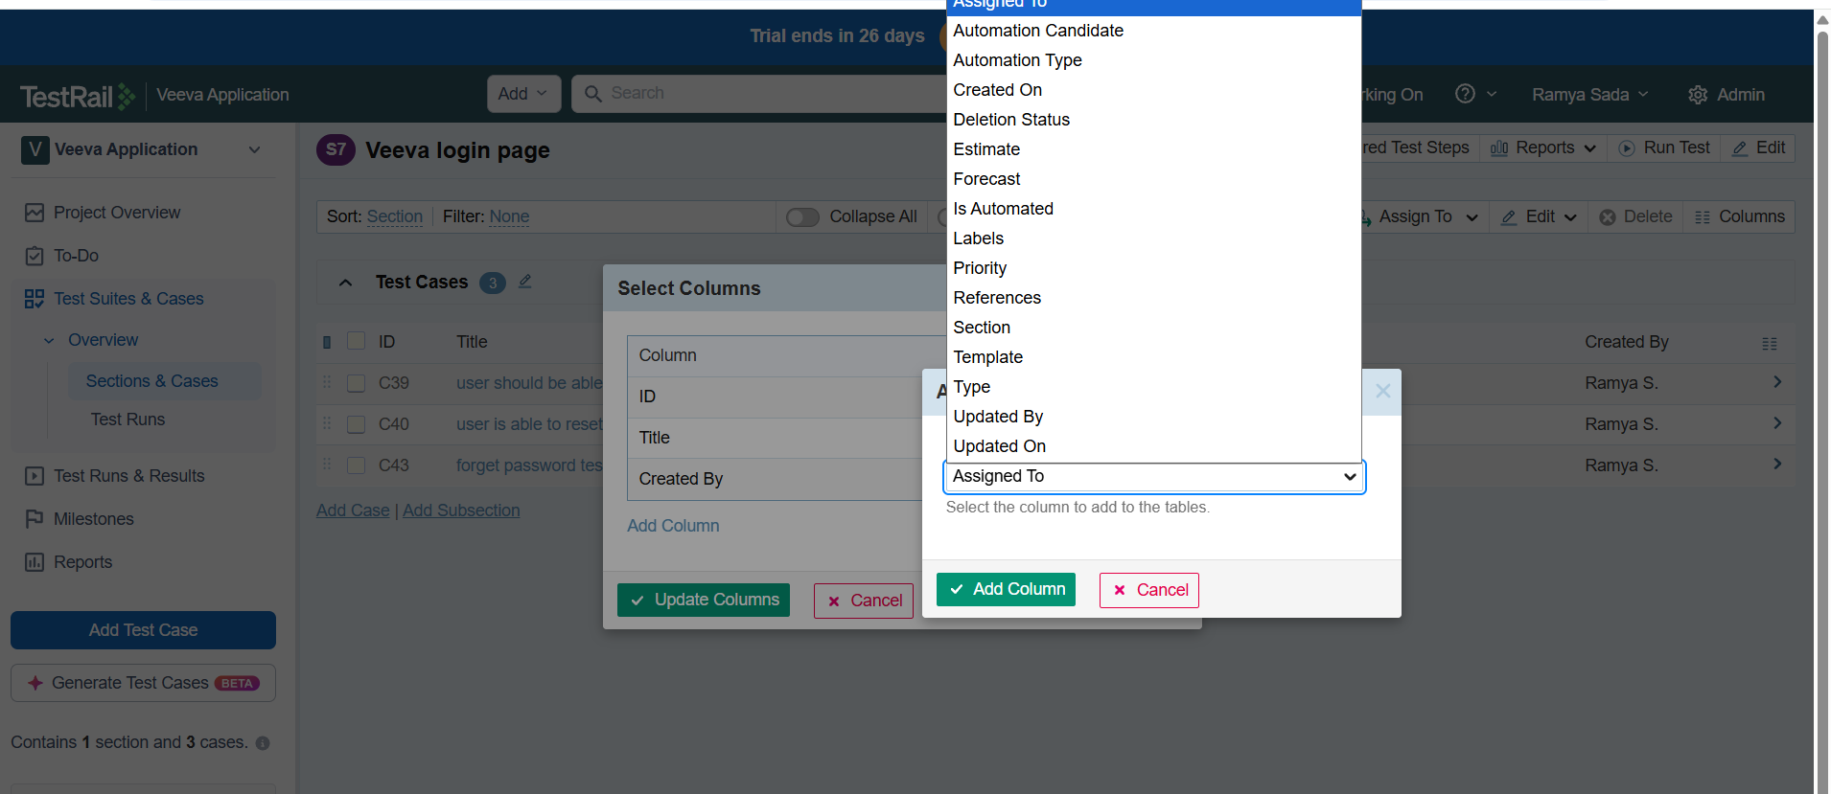

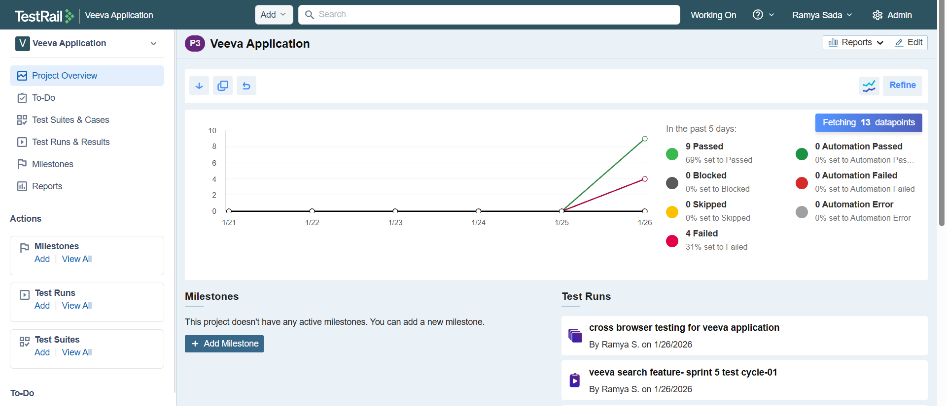

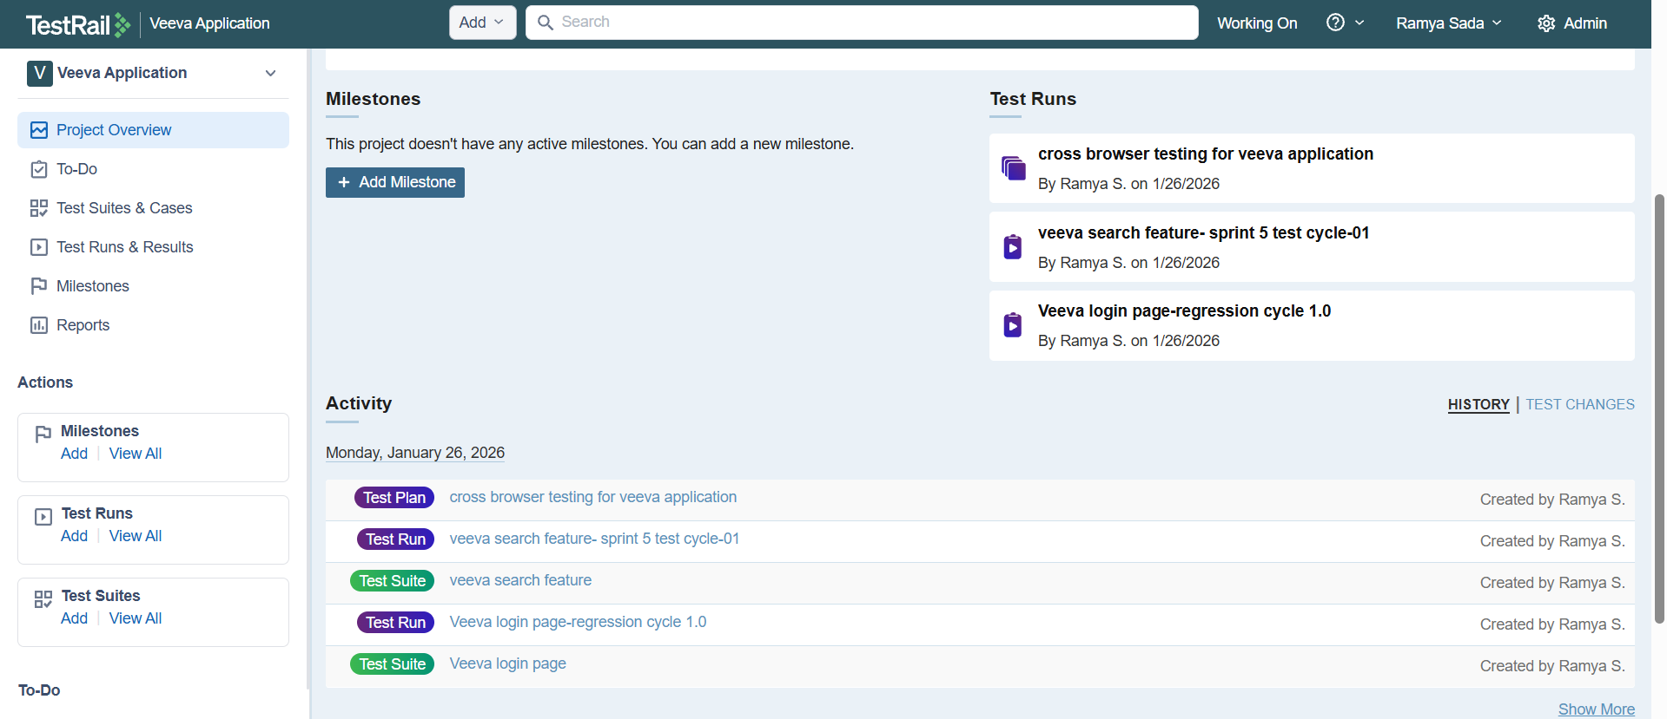

**Milestone**

**What is a Milestone?**

A **Milestone** in TestRail represents a **specific phase, version, or release** of a project with a **start date and end date**.

👉 Think of a milestone as a **target or goal** for testing.

**Example:**

* Sprint 1
* Release 2.0
* Regression Cycle – Jan 2026

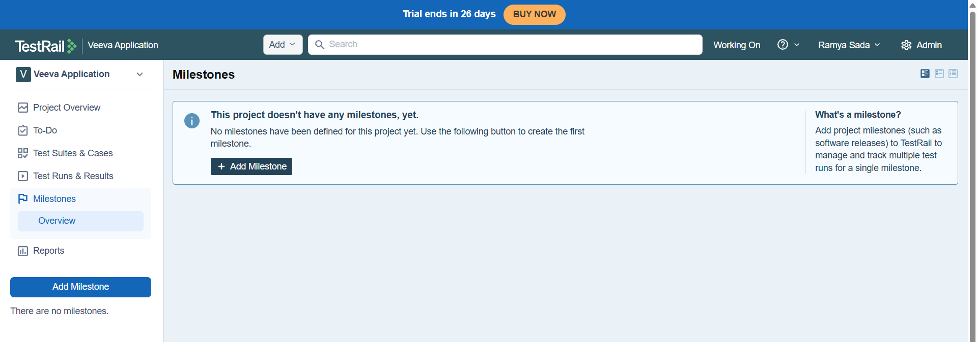

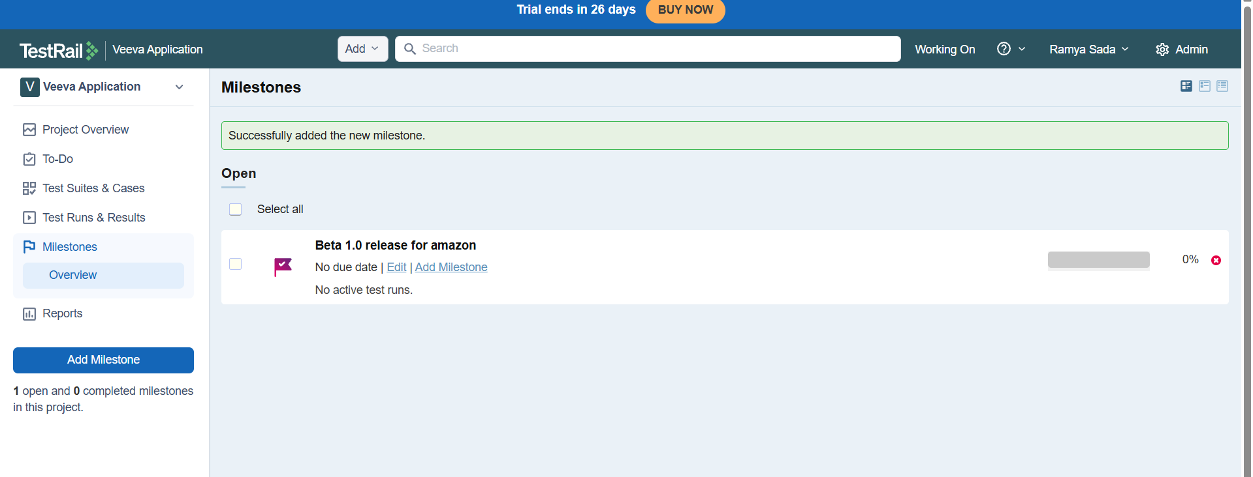

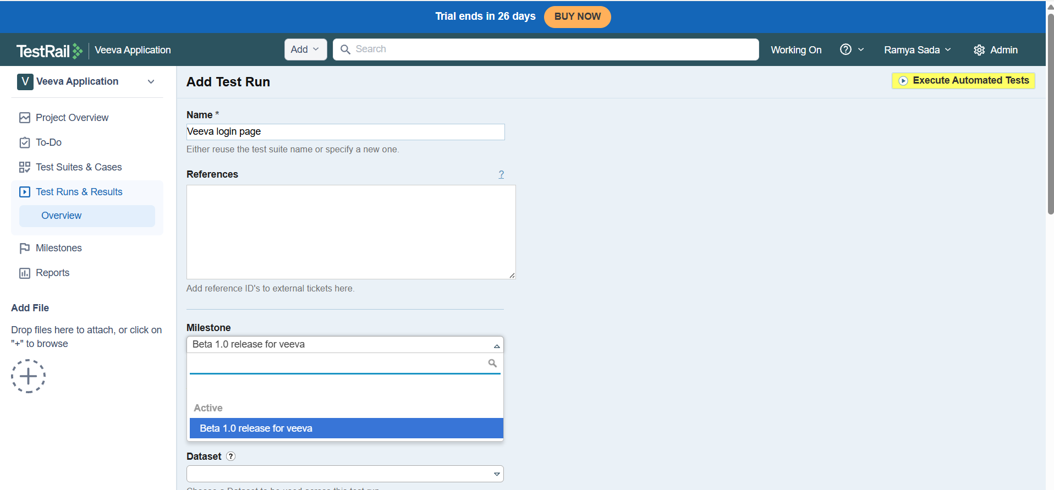

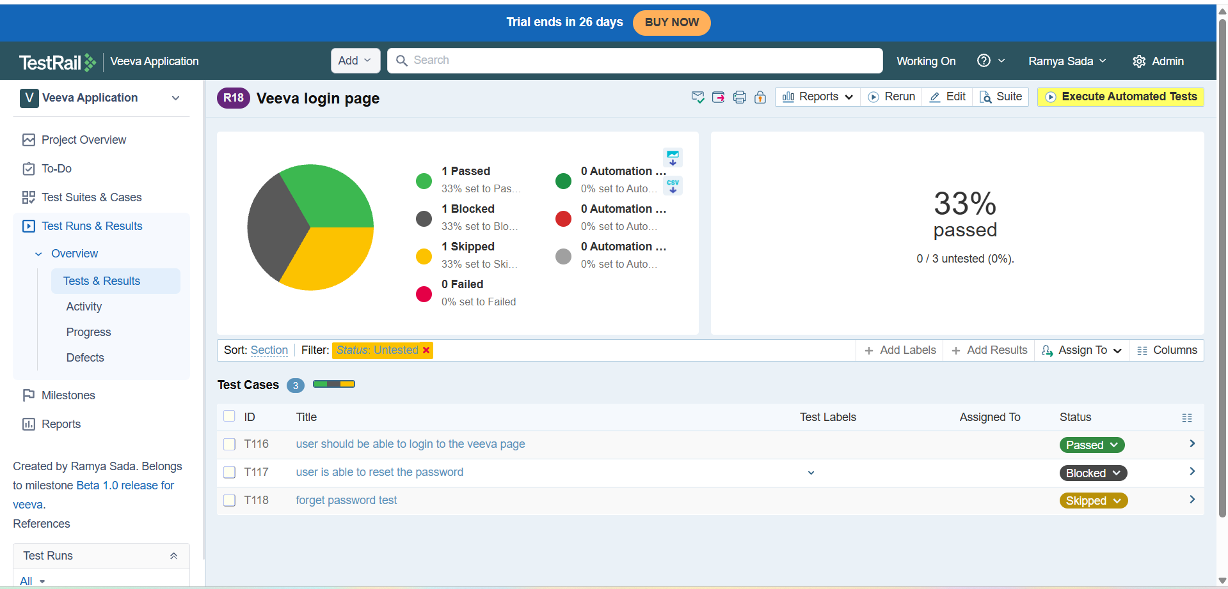

**Reports**

**Reports in TestRail** are used to **analyze, track, and share testing progress, results, and quality metrics** in a project.

👉 Reports convert test execution data into **charts, tables, and summaries**.

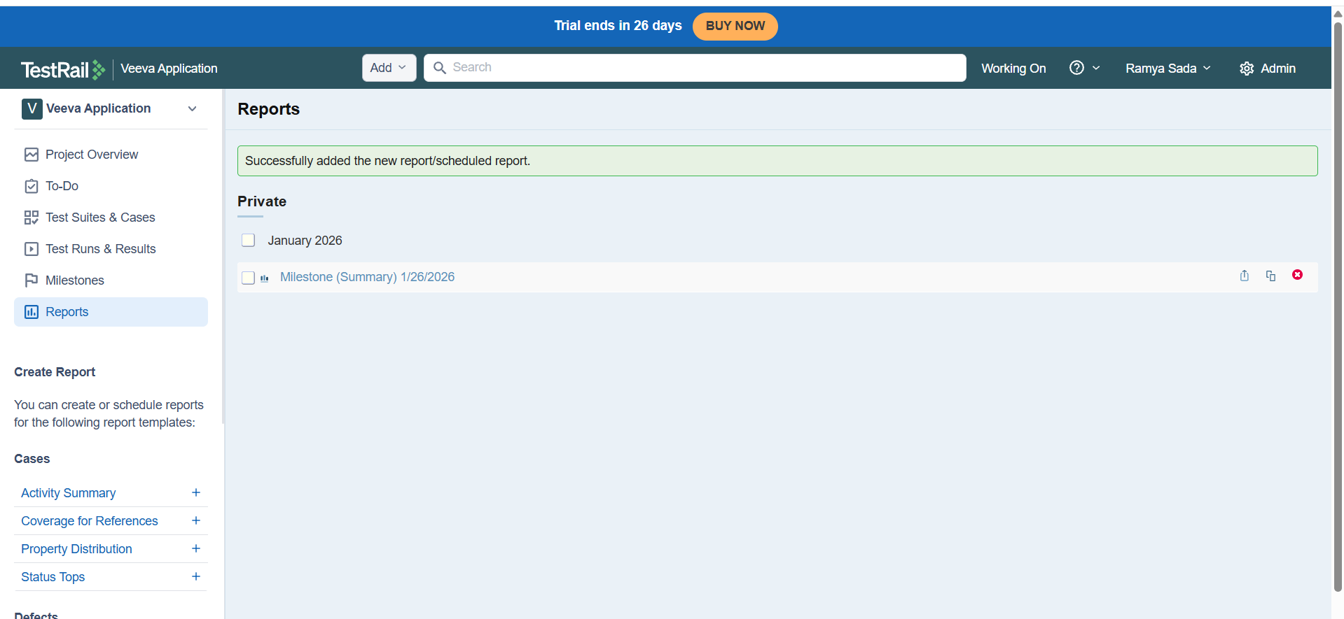

It creates report for the milestone we can also download it

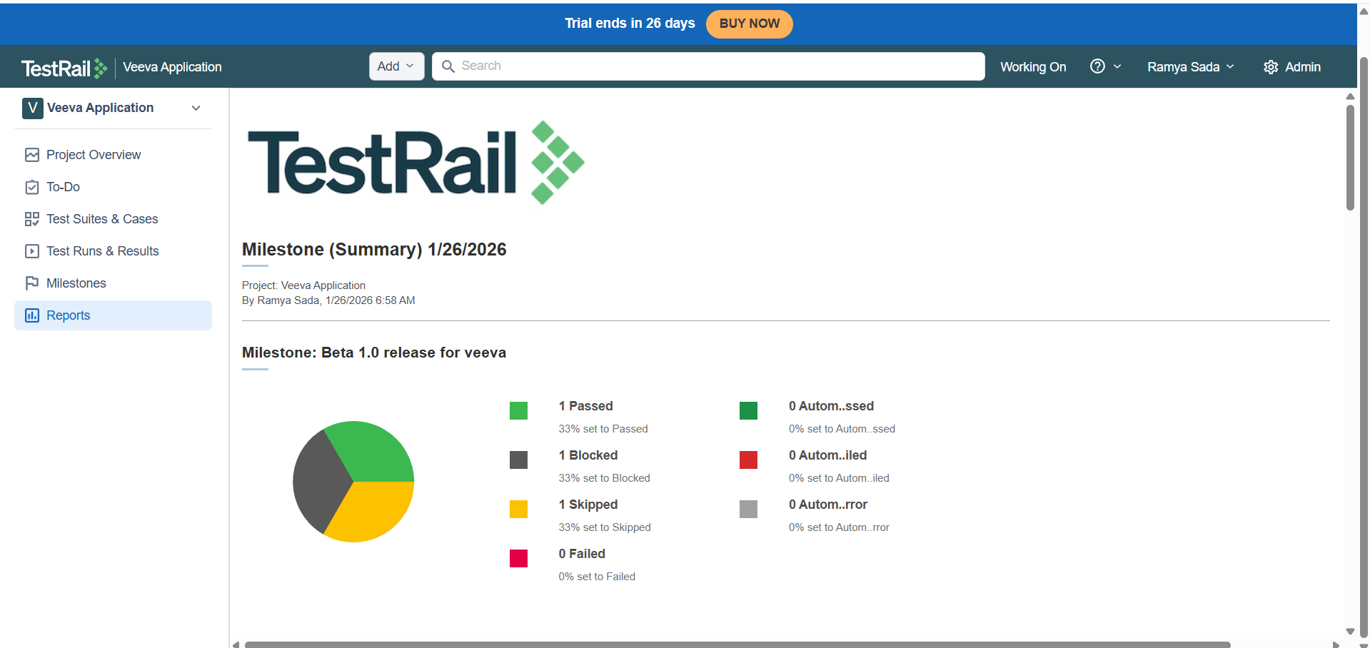

We can also add users

